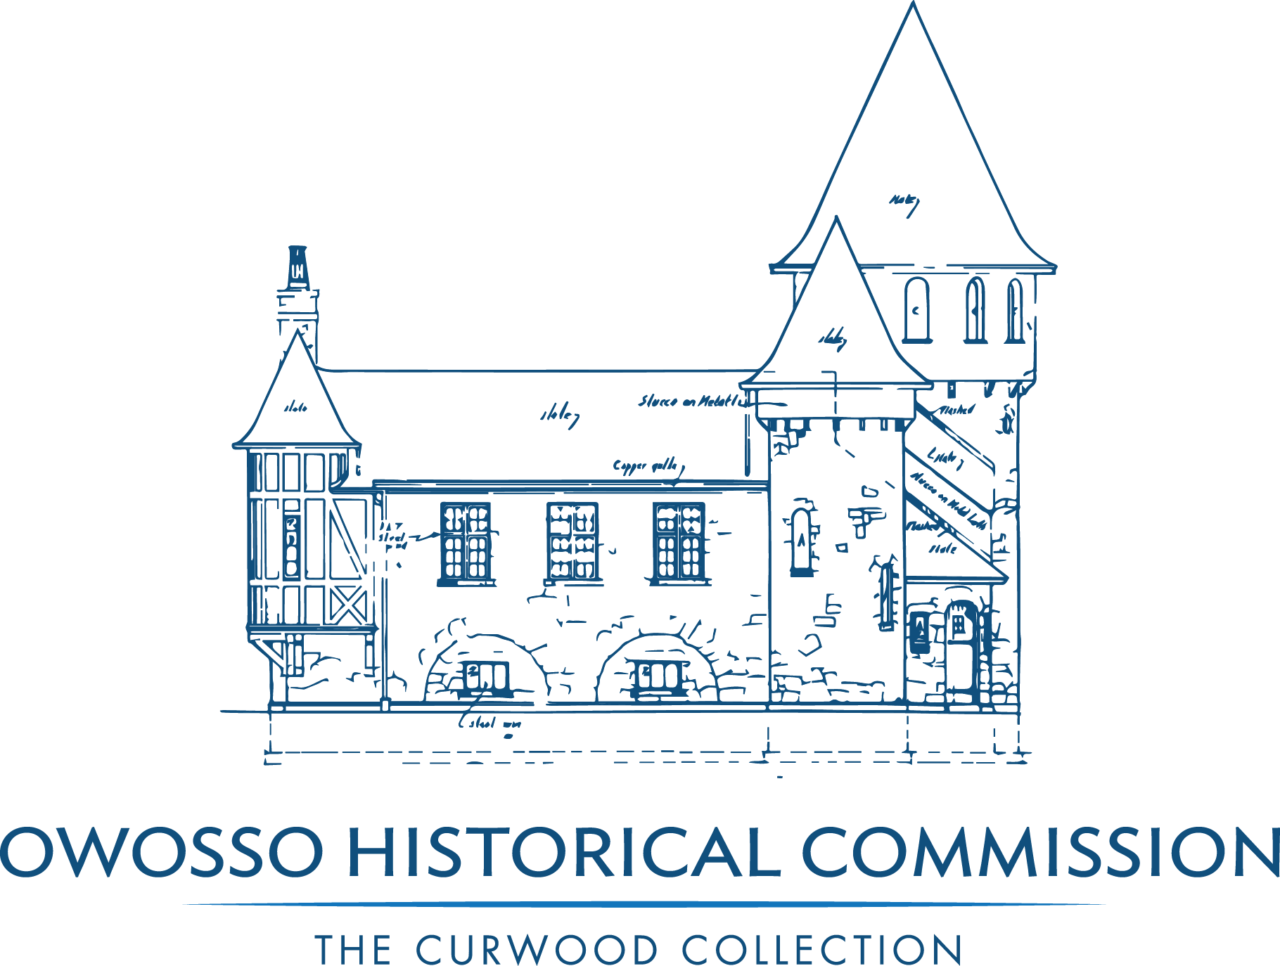
OWOSSO HISTORICAL COMMISSION
Regular Meeting Minutes
August 13, 2018, 7:00 PM Shiawassee Art Center

CALL TO ORDER: MEETING WAS CALLED TO ORDER AT 7:00 PM BY CHAIR CAROL VAUGHN

PRESENT: COMMISSIONER CAROL VAUGHN, CHAIR; COMMISSIONER KAREN MARUMOTO, VICE CHAIR; COMMISSIONER DAVE ACTON; CITY COUNCIL REPRESENTATIVE ELAINE GREENWAY; COMMISSIONER CAROLYN EBERT; COMMISSIONER HEATHER JACOBS; ROBERT DORAN, DIRECTOR

ABSENT: COMMISSIONER SARA ADAMS; COMMISSIONER DEB GILBERT;
COMMISSIONER ANNE LUDINGTON

APPROVAL OF AGENDA: Additions to Agenda were requested: Apartment renovation update – Old Business; Smithsonian Waterways Exhibit – New Business.
Commissioner Elaine Greenway motioned to approve Agenda with additions, supported by Commissioner Karen Marumoto.
AYES ALL, MOTION CARRIED.

APPROVAL OF JULY, 2018 REVENUE AND EXPENDITURE REPORT
Discussion occurred around the end of year adjustments to be audited
September, 2018.

Commissioner Dave Action motioned to approve the July 2018 Revenue and Expenditure Report, Supported by Commissioner Carolyn Ebert.
AYES ALL, MOTION CARRIED.

CONSENT AGENDA:
Curwood Castle Dashboard Report, OHC Dashboard Report, Curwood Castle Admissions and Financials, Curwood Castle Gift Shop Sales, OHC Balance Sheet, OHC Check Register; OHC July 9, 2018 Meeting Minutes.

Commissioner Karen Marumoto motioned to approve the Consent Agenda, supported by Commissioner Heather Jacobs.
AYES ALL, MOTION CARRIED.

CITIZEN COMMENTS: NONE

COMMUNICATIONS: NONE

OLD BUSINESS:

- Review Board Agenda 12 Month Planning Guide: Planning is on schedule with no stand out items.
- 501(c)3 status – Articles of Incorporation and Policies to be approved during Inaugural Board Meeting of the Castle City Museums after adjournment of this Owosso Historical Commission meeting. Financial reports to be completed. 30-Hour Consulting Grant from Cook Family Foundation denied.
- Follow-up on Fund Raising Seminar – Next Steps
Meet as a group to share work plans to compile individual ideas to clarify how to raise $1,000 funds per person and launch of Membership package. Summary packet of training yet to be received; Fund generating activities to be included in strategic planning. Ideas exchanged to generate donations.

- Museums and Parks Millage – Next Steps: PR Campaign
Language provided of proposal to be on November ballot presented. Capital improvement projects to be shown for 2-year period. A press release will be produced to announce plans for levying of millage. A committee will be formed to work on PR Campaign.

- OHC Schedule Review – Important Dates
- September 8 Owosso Art Walk
- October 19 Painting Exhibition
- October 27 Curwood Highlander
- November 1 Decorate Castle for Holidays
- November 15 Docent and Donor Recognition Awards
- December 6 Holiday Party and Silent Auction
- December 21 & 22 Christmas Extravaganza
A review of activities was provided by Director Doran.

- Apartment renovation update – Contractor will be contacted
to accomplish the renovations needed to begin renting again.
NEW BUSINESS:
- Committee Reports
  - Finance: No meeting held – IRS application will be reviewed with Jim Demis.
  - Governance: Worked on IRS Application, Discussed 5-Year Agreement with the City of Owosso regarding the relationship between the Owosso Historic Commission and Castle City Museums. Questions were outlined to address with City.
  - Philanthropy, Giving & Membership: No meeting held
  - Exhibitions & Education: Painting Exhibition, Offerings for next year including a review of products and services. Spoke with an individual that owns a large collection of Owosso Memorabilia Exhibit - possible fund raising event.
Smithsonian Waterways Exhibition – February 2019 SAC will receive exhibit. Owosso chosen as one of 6 cities chosen out of 25 applied. Ancillary exhibits, educational components will include Owosso Middle School poster contest and displayed at The Castle with a focus on “What does the Shiawassee River mean to me.”
Motion was made by Commissioner Dave Acton to participate with SAC in the Smithsonian Waterway Exhibition with Castle Involvement, supported by Commissioner Heather Jacobs.
All Ayes. Motion Carried.
  - Facilities: Contractors were contacted to begin work at the Comstock Cabin as previously reported.
  - Marketing, Advertising & Social Media: Work plans were developed on Exhibitions with focus on increasing visitors at the Castle, both new and returning visitors.
  - Archiving & Acquisitions: Archiving has begun - Software will be on the computer by August 31st. Materials have been ordered to begin archiving the materials designated in the Great Room totaling $330 to be done by December 2018. Past Perfect Software support cost discussed.
  - Volunteers: Term volunteer changed to Docents. Strategies developed to increase docents.
- Paintings & October 19 exhibition – Discussed.
- Sponsorships – Discussed.
- Memberships – Discussed.
- Power thought of the day – Involvement encourages commitment.

CITIZEN COMMENTS: NA

ADJOURN: Commissioner Dave Acton motioned to adjourn at 8:20, motion supported by Commissioner Heather Jacobs.
AYES ALL, MOTION CARRIED.

NOTE: Inaugural Board Meeting of Castle City Museums held immediately after adjournment of this
Owosso Historical Commission meeting.

